How to Order: VALVE PARTS

Costumer Information:

Company Name: |  | Contact:
City & State: |  | Phone:
Email: |  | Fax:

VALVE INFORMATION:

Valve Style: FC Style, WKM Style, DEMCO Style, Others:

VALVE PARTS:

GATE | Size | Qty | Annual Usage | Pressure | Material
GATE | 1-13/16” |  |  | 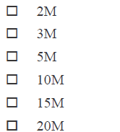 | 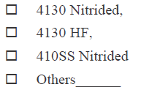
GATE | 2-1/16”
GATE | 2-9/16”
GATE | 3-1/8”
GATE | 4-1/16”
GATE | 5-1/8”
GATE | 7-1/16”
SEAT | Size | Qty | Annual Usage | Pressure | Material
SEAT | 1-13/16” |  |  |  | 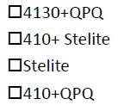  □Others
SEAT | 2-1/16”
SEAT | 2-9/16”
SEAT | 3-1/8”
SEAT | 4-1/16”
SEAT | 5-1/8”
SEAT | 7-1/16”
STEM | Size | Qty | Annual Usage | Pressure | Material
STEM | 1-13/16” |  |  |  | 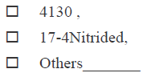
STEM | 2-1/16”
STEM | 2-9/16”
STEM | 3-1/8”
STEM | 4-1/16”
STEM | 5-1/8”
STEM | 7-1/16”

BODY BUSHING | Size | Qty | Annual Usage | Pressure | Material
BODY BUSHING | 1-13/16” |  |  |  | 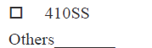
BODY BUSHING | 2-1/16”
BODY BUSHING | 2-9/16”
BODY BUSHING | 3-1/8”
BODY BUSHING | 4-1/16”
BODY BUSHING | 5-1/8”
BODY BUSHING | 7-1/16”
BONNET GASKET | Size | Qty | Annual Usage | Pressure | Material
BONNET GASKET | 1-13/16” |  |  |  | 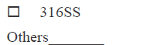
BONNET GASKET | 2-1/16”
BONNET GASKET | 2-9/16”
BONNET GASKET | 3-1/8”
BONNET GASKET | 4-1/16”
BONNET GASKET | 5-1/8”
BONNET GASKET | 7-1/16”
BODY | Size | Qty | Annual Usage | Pressure | Material
BODY | 1-13/16” |  |  |  | 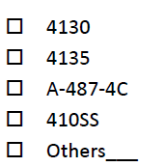
BODY | 2-1/16”
BODY | 2-9/16”
BODY | 3-1/8”
BODY | 4-1/16”
BODY | 5-1/8”
BODY | 7-1/16”

